## **Settings and regulations before using the program**

Based on Excel2010 settings:

### Load Planning Solution

The specific steps for the 2010 version of Excel load planner add-in are as follows:

* + - 1. Click "Microsoft Office Button" and then "Excel Options".
      2. As shown in Figure 1, in the "Excel Options" dialog box that appears, click "Add-ons", then select "Solution Add-ons" in the right box, and then click "Go".
      3. In the "Available Add-ons" box, select the "Analysis Tool Library", "Analysis Tool Library-VBA" and "Solver Add-in" check boxes, and then click "OK", as shown in Figure 2.

After the Solver add-in is loaded, the Solver command appears on the Add-ons tab.

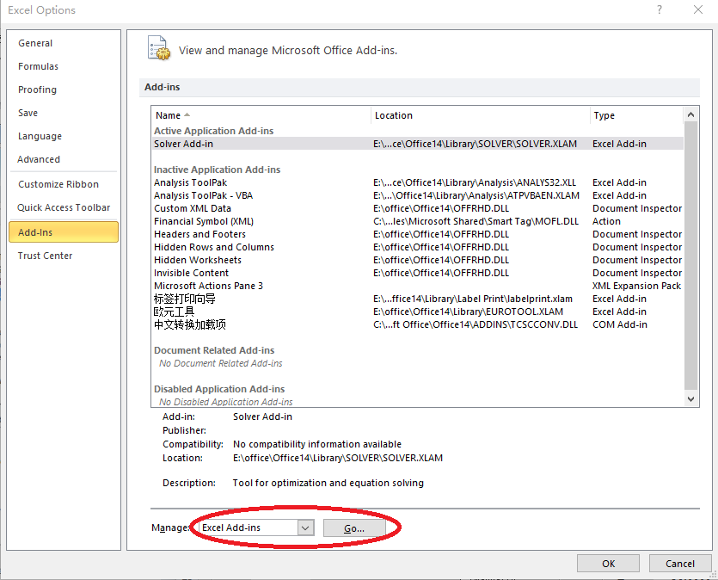

**Figure 1 Select Solver Add-in**

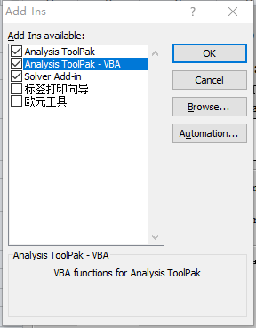

Figure 2 Enable Solver Add-ons

### Macro Security Settings

In Excel2010, you can find the "Microsoft Office Button" in the Trust Center-"Excel Options"-"Trust Center Settings"-"Macro Settings" category (Figure 3), Select "Enable all macros", or "Development tools" tab-"Code" group-"Macro security" button to change the macro's security settings. You can also add a spreadsheet in "Trusted locations" Dam.xlsm is located.

After completing these settings, a security warning will still pop up on the toolbar every time the dam-breaching electronic meter is opened. Click the "Options" button, select "Enable this content" in the pop-up "Microsoft Security Options" dialog box, and then click "OK".

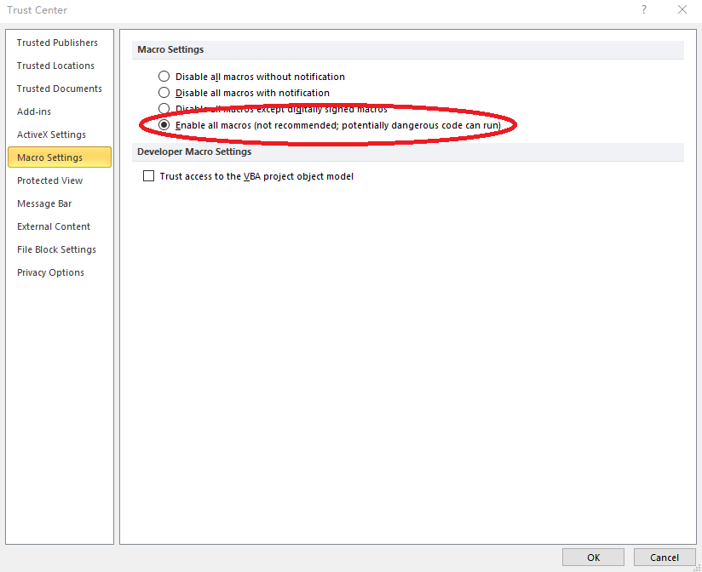

Figure 3 Macro settings in Excel 2010

### "Project or Library Not Found" Processing

Due to the compatibility of different versions of Excel, the following problems may occur in use. When you click any menu button created in a dam-breaching spreadsheet, an error message "Project or library cannot be found" pops up, as shown in the Figure 4. The reason for this is that Solver (Solution Solver) is not correctly referenced (caused by the inconsistent language used by each version of Solver).

The solution is as follows:

1) Click the "OK" button in the pop-up window, and the program is now running in Visual Basic.

2) Stop running: First enter a space at the end of a line in the code window (the purpose of entering a space is to quickly stop running without changing the program), and then click the "Reset" button on the toolbar, or "Run" The "Reset" command on the menu is shown in Figure 5.

3) Click the "Reference" command on the "Tools" menu. In the pop-up dialog box, remove the check box in front of "Lost Solver".

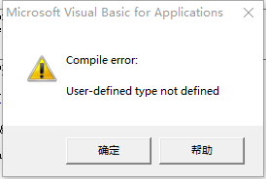

**Figure 4 Compile error**

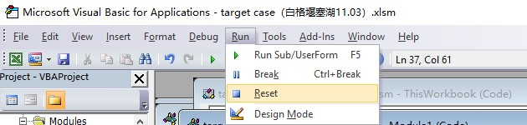

Figure 5 Interrupt VBA Run

4) Switch to the Excel worksheet window, click the "Solver" command on the "Data" menu, and then click the "Close" button in the "Solver" window that pops up.

5) Switch back to the VBA window, click the "Reference" command on the "Tools" menu, and you will find that "Lost Solver" has become "Solver" in the pop-up dialog box. Select the previous check box and click "OK" button, such as Figure 6.

In this way, the "cannot find project or library" error problem can be solved.

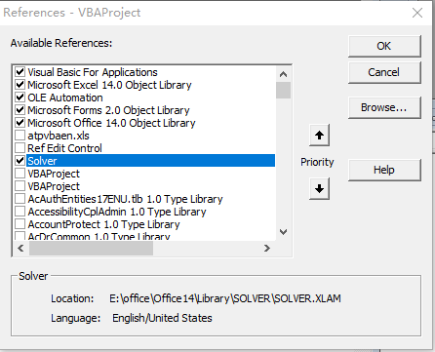

Figure 6 solver is missing